./

Learning Report – Applied System Development Life Cycle and Software Testing



|  |  |  |  |  |  |
| --- | --- | --- | --- | --- | --- |
| **Ver. Rel. No.** | **Release Date** | **Prepared. By** | **Reviewed By** | **To be approved By** | **Remarks/Revision Details** |
| 1 |  | Name/PS No | Name/PS No | Module Owner Name | Comments |
| 2 | 15/02/21 | U.Vijay/99003768 |  |  |  |
| 3 |  |  |  |  |  |
|  |  |  |  |  |  |
|  |  |  |  |  |  |

**Document History**

Table of Contents

ACTIVITY 1: SYSTEM/ SOFTWARE DEVELOPMENT………………………………………………………………………………………………………..4

**INTRODUCTION………………………………………………………………………………………………………………………………………………………4**

**MY PRODUCT: “Name ”……………………………………………………………………………………………………………………………………………4**

**SWOT ANALYSIS……………………………………………………………………………………………………………………………………..4**

**REQUIREMENTS………………………………………………………………………………………………………………………………………….5**

**DESIGN** **6**

HIGH LEVEL DESIGN **6**

LOW LEVEL DESIGN **7**

**TEST PLANS****9**

ACTIVITY 2: AGILE METHODOLOGY 9

**PHASES IN AGILE MODEL**……………………………………………………………………………………………………………….……………..**10**

## Table of Figures

Figure 1 USE CASE DIAGRAM (HIGH LEVEL) 11

Figure 2 PACKAGE DIAGRAM (LOW LEVEL) 12

Figure 3ACTIVITY DIAGRAM (LOW LEVEL) 13

Figure 4 TEST PLAN 14

Figure 5 GIT 15

Figure 6 GIT ISSUES 15

**ACTIVITY 1: SYSTEM/ SOFTWARE DEVELOPMENT**

INTRODUCTION:

Calculator is basically used to perform simple calculations but it can also be used to perform complex as well as scientific calculations. Calculators are portable, hence they can be taken to any location. They are also very handy to use.

**MY PRODUCT: “CALCULATOR”**

**SWOT ANALYSIS**

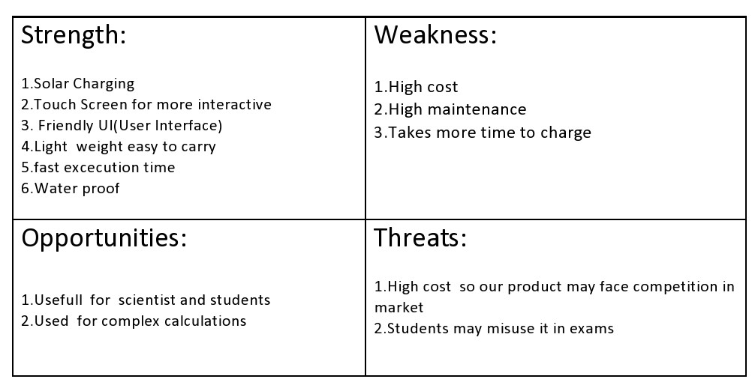

**REQUIREMENTS**

## **High Level Requirements:**

* **Arithmetic**
* **Area calculator**
* **Complex operation**
* **Trigonometric calculation**
* **Temperature conversion**
* **Volume calculation**
* **Discount calculation**
* **Interest calculation**
* **Length converter**
* **Square root function**
* **Matrix calculation**
* **Factorial calculation**
* **HCF**
* **LCM**

## Low level Requirements:

* **Addition, subtraction, multiplication, division modules.**
* **Length, breadth, height.**
* **Fahrenheit, Celsius temperature values.**
* **BODMAS.**
* **formulae for trigonometric calculations.**
* **Allow Digits 0-9.**
* **Dedicated on and off button.**

**DESIGN**

**HIGH LEVEL DESIGN:**

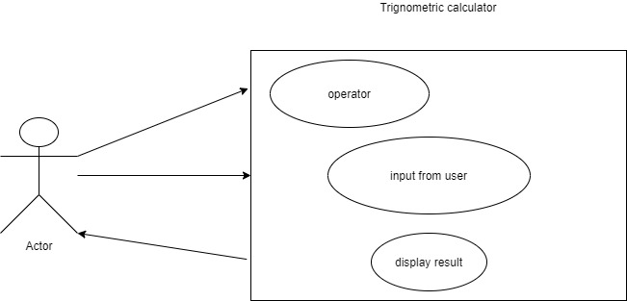

**LOW LEVEL DESIGN**

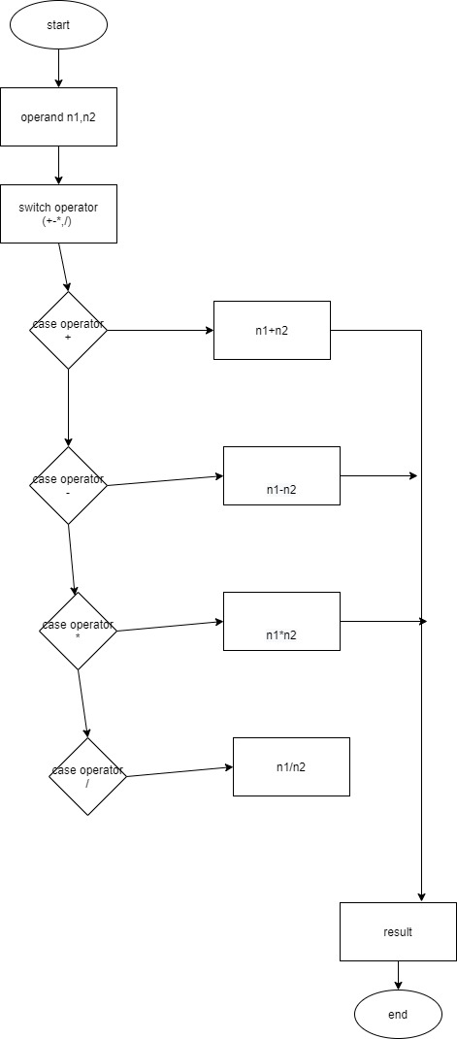

Activity diagram for arithmetic operations Low level

Low level diagram for temperature conversion

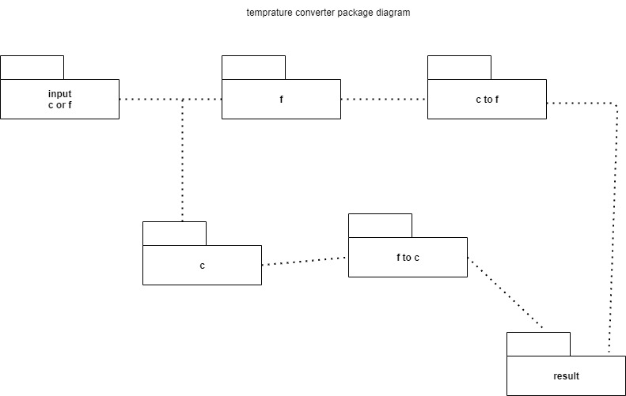

TEST PLANS

|  |  |  |  |
| --- | --- | --- | --- |
| Test ID | Description | Expected input | Expected output |
| 1. | 2nd operand is zero | 3/0 | Cannot divide by zero |
| 2. | Length of input exceeds the range | 9652658822 | Out of range error |
| 3. | Multiplying two 10 bit numbers | 9696562547*9696854711 | Range out of bound |

ACTIVITY 2: AGILE METHODOLOGY

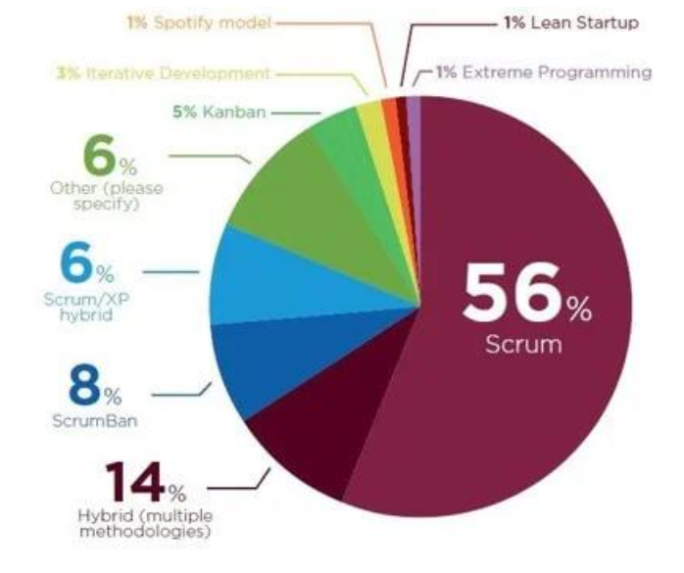

Phases in agile model:

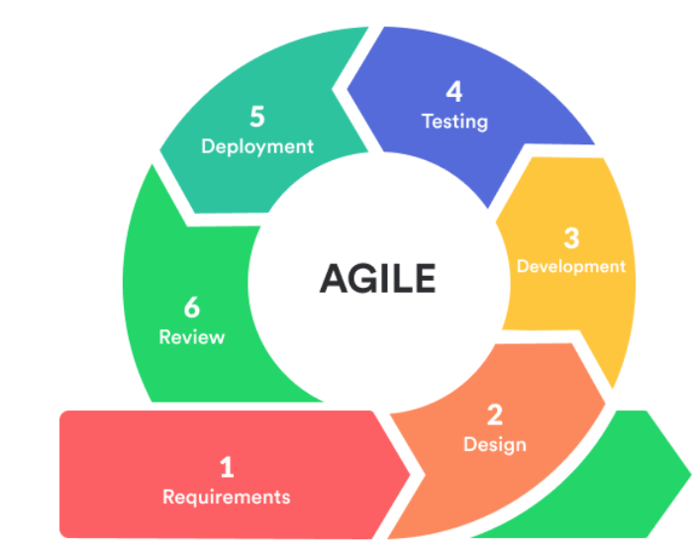

## Table of Figures

Figure 1: USE CASE DIAGRAM (HIGH LEVEL)



FIGURE 2: LOW LEVEL PACKAGE DIAGRAM



FIGURE3: ACTIVITY DIAGRAM FOR ARITHMETIC OPERATIONS:



FIGURE 4: TEST PLAN

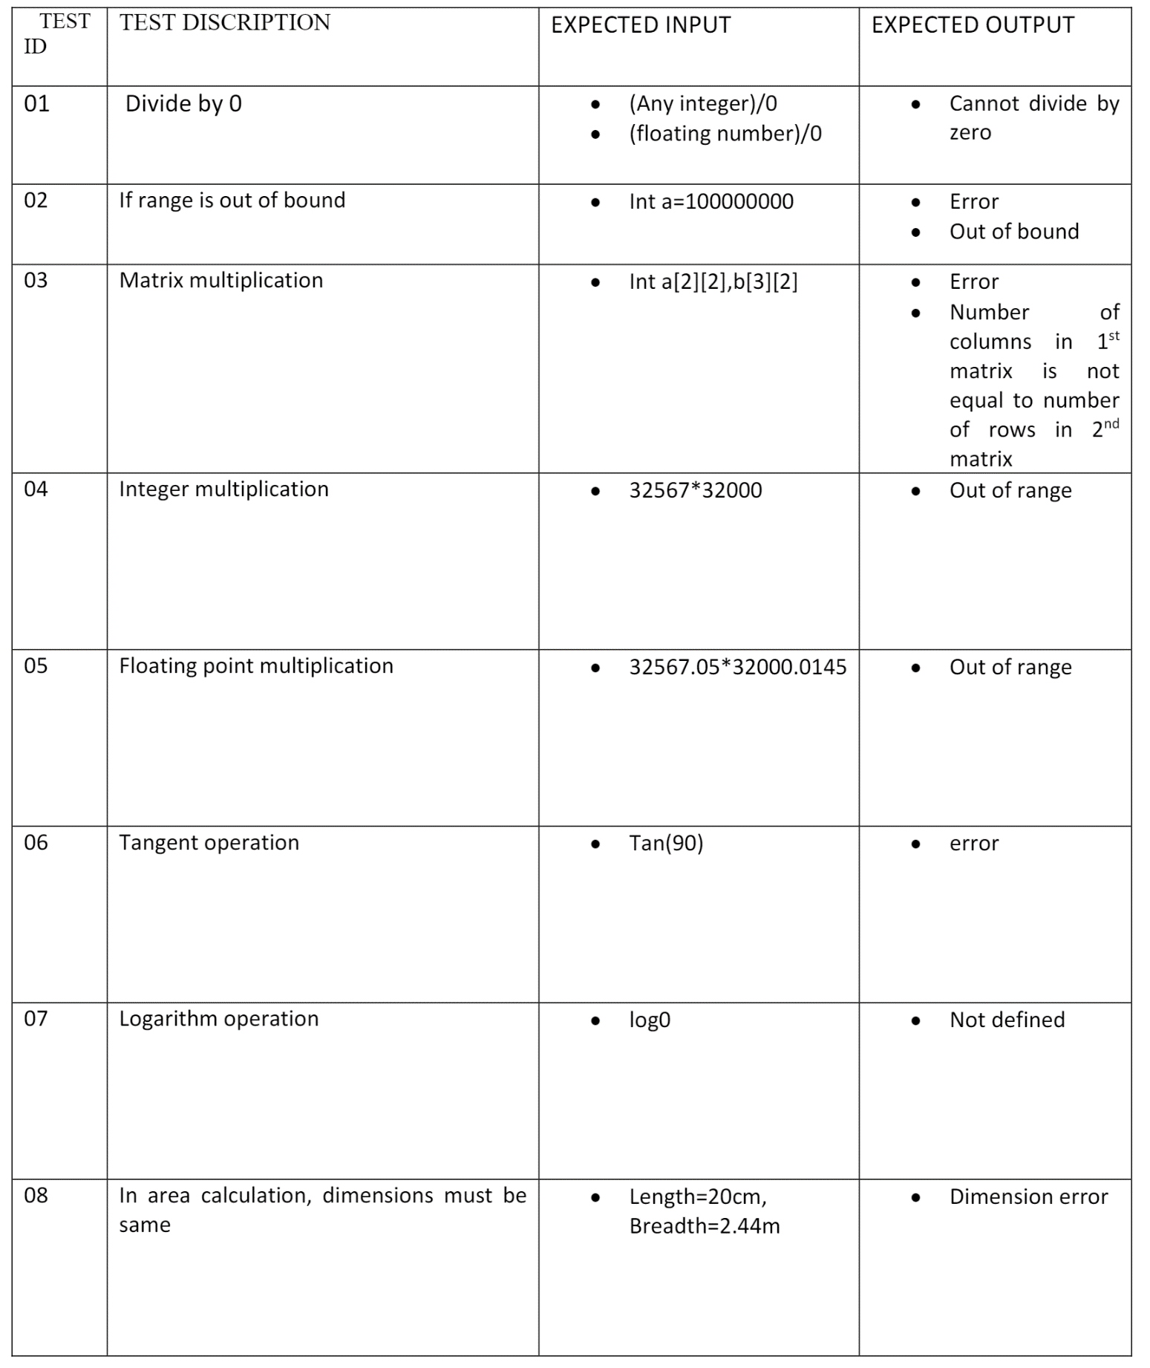

GIT Commits:

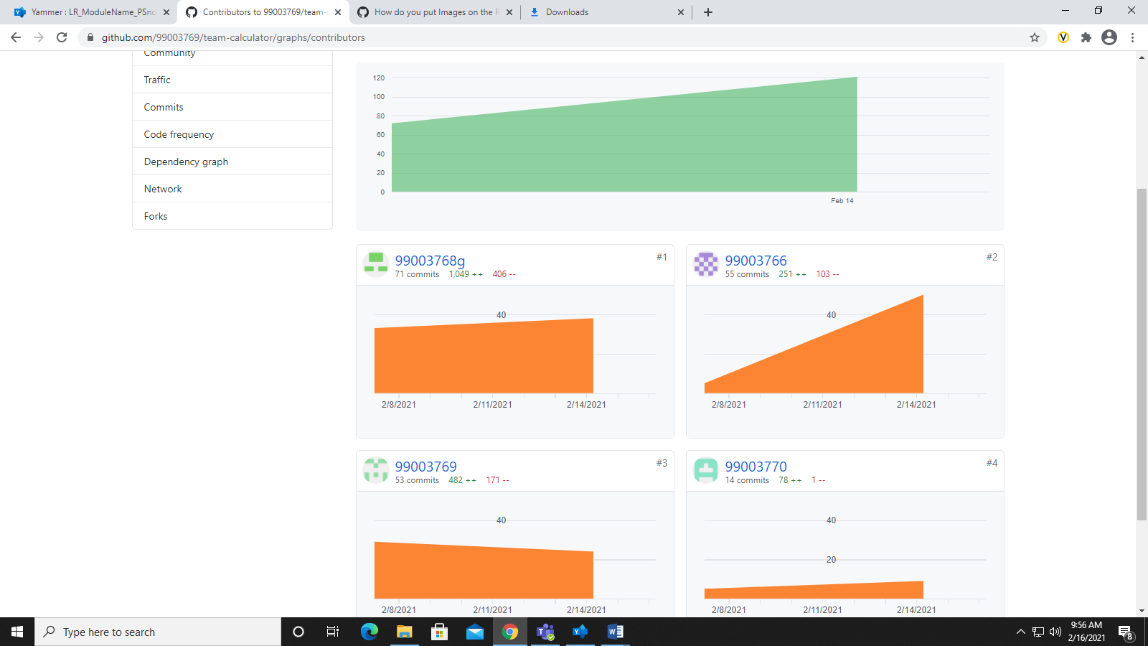

Git issue:

